Housing Agency Housing Education Bursary Scheme 2019/2020
The Housing Agency is delighted to launch its Housing Education Bursary Scheme for the 2019/2020 academic year.

In 2019 and 2020 significant efforts have been made in the areas of housing delivery and policy development. We have reflected on the importance of the role that housing professionals play and wish to promote current housing education and training programmes and support the development of housing practitioners.

Key Information
The Bursary Scheme is available in relation to the courses detailed below. Applicants can apply for a bursary in relation to courses for the 2019/2020 academic year by filling out this enclosed bursary application form and personal statement and submitting it to the Housing Agency (further details enclosed).

It is intended that the bursary assists those that would otherwise be unable to secure funding for the full course fees from their organisation, or cover the full fees themselves this year.

It is important that you also fill out the course providers’ standard course application form and apply, as normal, to either the Institute of Public Administration (IPA) or the Chartered Institute of Housing Ireland (CIH). It would be useful to enclose a note to say that you have applied for the bursary.

Course application forms are available at the hyperlinks set out below.

The closing date for this bursary scheme is Wednesday 28th August 2019 (noon). It is envisaged that notifications will be made by the end of August.

We have 15 bursaries of 50% of course fees to offer. In exceptional circumstances there may be a higher percentage awarded. Successful applicants will have credit lodged with the nominated course provider on the successful commencement of the nominated course. The balance of fees will be payable to the course provider as normal.

Courses that can be subsidised with the Bursary
Level 4 Certificate in Housing (September 2019 start)
http://www.cih.org/Blended_learning_Level_4
IPA New Thinking For Housing (October 2019 start)
https://www.ipa.ie/local-government/new-thinking-for-housing.3966.html
IPA Level 6 Certificate in Housing Studies (September 2019 start)
https://www.ipa.ie/local-government/certificate-in-housing-studies.2896.html
IPA Level 8 Professional Diploma in Housing Studies (September 2019 start)
https://www.ipa.ie/local-government/professional-diploma-in-housing-studies.1869.html

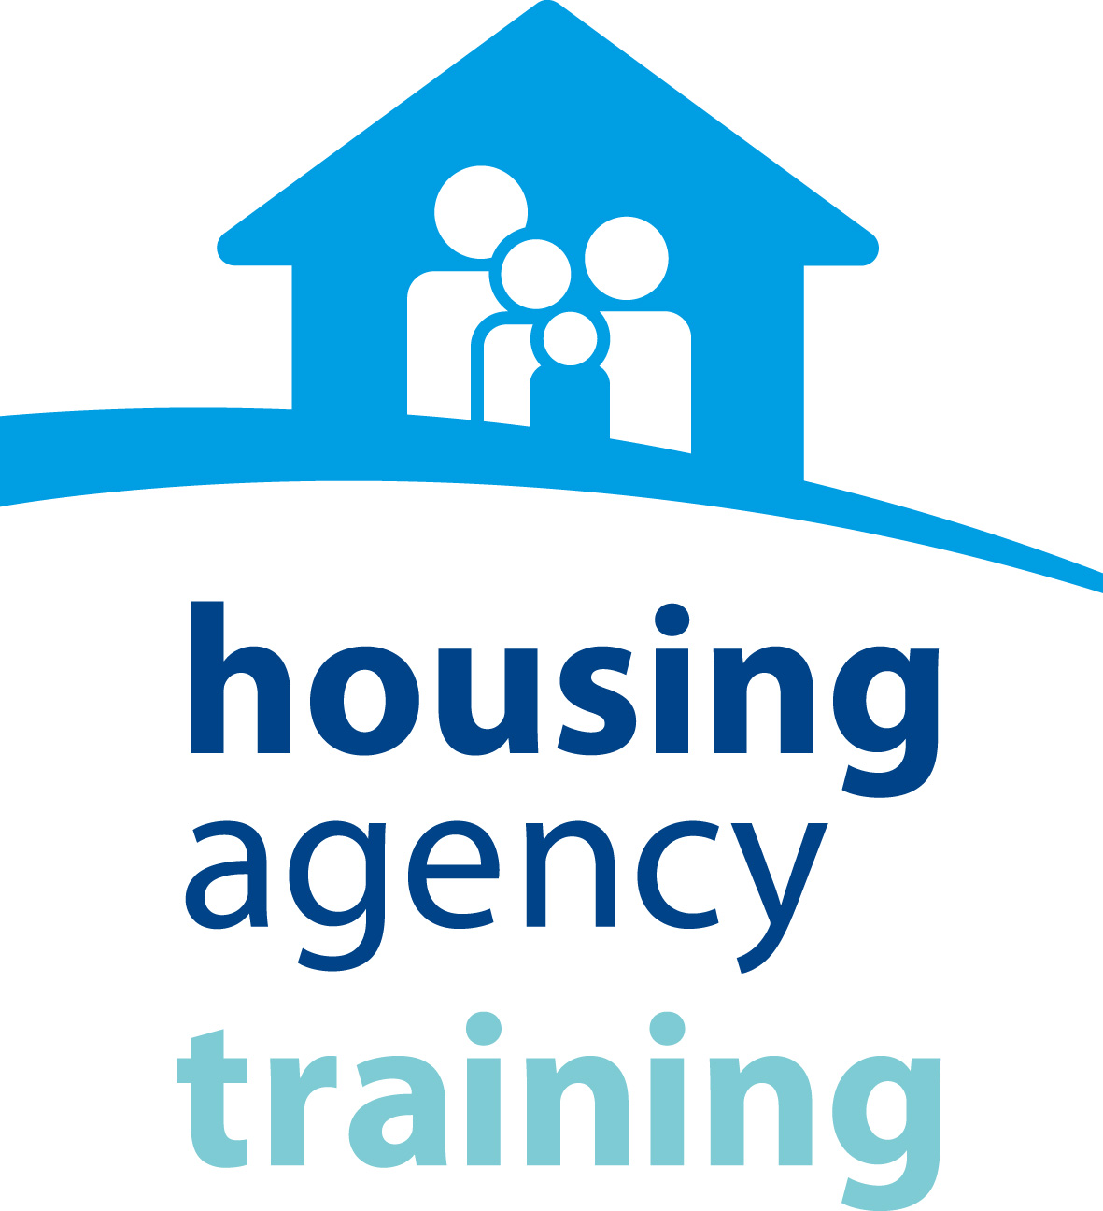
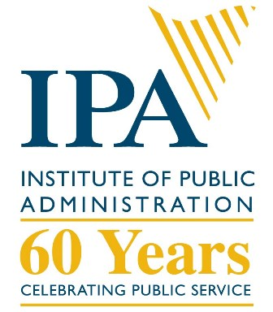

Application Form
for
Housing Agency
Housing Education Bursary Scheme
2019/2020

Closing Date: Noon, Wednesday 28th August, 2019.
Submission: By email only to training@housingagency.ie

☐ Please tick the box to confirm consent to the Housing Agency processing your application in accordance with the Privacy Statement detailed at Appendix 2.

Disclaimer: please consult the documentation to ensure that you are qualified to apply for the course for which you are seeking funding. All applications will be assessed by a panel at the Housing Agency. Not all applicants may be successful, subject to funding available.

Application Form for Housing Agency Housing Education Bursary 2019/2020
Please insert any additional space, as required
Name
Organisation
Job Title
Email
Contact ph.
Course which you are applying for
(Please consult course descriptors at Appendix 1 and insert an ‘x’ in one box only. Ensure to apply for the course as normal noting that you have also applied for this bursary)
☐ |  | Level 4 Certificate in Housing (September 2019 start)
☐ |  | http://www.cih.org/Blended_learning_Level_4
☐ |  | IPA New Thinking For Housing (October 2019 start)
☐ |  | https://www.ipa.ie/local-government/new-thinking-for-housing.3966.html
Past training/education
(Please give a brief description of any previous degrees/diplomas/training etc – this does not have to be housing related and is just to give context regarding your career to date)
Year(s) | Details
Details of role(s) with you current organisation
Year(s) | Main responsibilities
Summary of other previous roles
(Here you can provide a short narrative on your work history as desired e.g. I spent 5 years in customer service before joining X, I spent 2 years in retail, etc)

Personal Statement
(Here we would like you to set out a short statement on why you want to partake in the course you have selected, why bursary funding would be of assistance and how participation will benefit your professional development/your organisation) MAX 500 Words

Appendix 1 – Course Details
The following is some overview information, full details can be found at the hyperlinks set out.
CIH Level 4 Certificate in Housing
http://www.cih.org/training/display/vpathDCR/templatedata/cih/training/data/NI/ROI/CIH_Level_3_Cert_Housing_Practice

The Level 4 Certificate in Housing is a one year blended vocational qualification, delivered through a combination of online and face-to-face learning it is comparable to the first year of an undergraduate degree, which explores areas of housing policy, law, finance, and professional practice. The qualification is made up of the following six units:
• Financing for housing
• Housing law
• Housing policy
• Professional practice skills for housing
• Housing management services
• Managing people and change.

How will the course benefit me and my organisation?
Gaining a qualification is a great way to develop your career prospects. The Level 4 qualification will enable you to be an effective housing practitioner and will provide you with a deeper understanding of how your organisation and others in the housing industry work. Successful completion of this course will enable learners to progress to the Level 5 Diploma in Housing, which leads to CIH chartered membership.
Download the qualification overview for further details
The option of free CIH membership is provided during the period of study for your qualification.

Who can apply?
To register for the qualification you should, as a minimum requirement, have completed one of the following:
• The CIH Level 3 Certificate in Housing Practice
OR
• An equivalent Level 3 qualification.

If you do not meet this minimum requirement but have relevant experience working in the housing sector, your application may also be considered.

You will be asked to provide evidence of your qualifications and/or your experience of working in the housing sector as part of the application process.

What does the qualification cost and how long does it take?
Duration: 12 months, delivered through a combination of online learning and seven face-to-face study days.
Qualification cost: £2,520
New Thinking For Housing
https://www.ipa.ie/local-government/new-thinking-for-housing.3966.html

The New Thinking for Housing Workshop Dates are as follows:
Workshop 1: 3 October 2019
Workshop 2: 19 November 2019
Workshop 3: 27 February 2020
Workshop 4: 28 February 2020
Workshops take place from 10:00am to 5:00pm .

A dinner will also be provided after Workshop 3 (Day one of the two days of workhops in February 2020).
All workshops take place at the IPA, Dublin 4.

Commences
3 October 2019 Bookings for these workshops close one week in advance of start date.

Entry Requirements
This programme is specifically for Housing Managers in Irish Local Authorities and Approved Housing Bodies.

Duration
Four Days
Accreditation
Housing Training Network
Fees & Enrolment
Fee: To obtain the maximum benefit, attendance at all four workshops is recommended. The cost of attendance at the full four seminars is €750 per person. A financial contribution of €250 per person will be made by the Housing Agency, for those attending all four workshops bringing the cost of the four workshops down to €500 per person.

Fee includes workshops documentation, morning coffee and lunch on workshop dates.
Booking: Bookings must be received in writing using a booking form or the online booking option (see below).
Numbers attending this series are limited to 25 people so early booking is recommended to secure a place.

Bookings must be received in writing using the form below or booking online and places will be allocated on a first come, first served basis.

All bookings will be confirmed via email. Please send completed booking forms to:
Central Bookings Office
Institute of Public Administration
57-61 Lansdowne Road, Dublin D04 TC62
Tel:(01) 240 3666 | Fax: (01) 668 9135
Email: training@ipa.ie
Cancellation Policy: Please note, that in the event of a cancellation less than 48 working hours before the commencement of a workshop, a 15% cancellation fee will be charged. Cancellation fee will also apply to non-arrivals on the day.

Progression
Participants may also be interested in the following IPA Courses:
Certificate in Housing Studies
Professional Diploma in Housing Studies

Level 6 Certificate in Housing Studies
https://www.ipa.ie/local-government/certificate-in-housing-studies.2896.html

The Certificate in Housing Studies is of huge benefit to housing practitioners, in both generalist and technical positions, in local authorities and approved housing bodies. It provides a system-wide induction to public/social housing—an area of huge national importance—in a practical and applied manner. The programme will also appeal to anyone working in related areas who would like to understand the evolution of housing policy in Ireland and the work of those bodies responsible for the delivery of housing services.

Delivery Method
This is a part-time course delivered through blended learning. Students attend weekday seminars at the IPA campus in Dublin between September and March.
Entry Requirements
Applicants require a Leaving Certificate with a minimum of grade C in two higher level papers and grade D in four other subjects. However, applicants that are over 21 on the calendar year of entry may also enter the programme without that requirement.
Duration
One academic year
Accreditation

Place on NFQ
Level 6 (Minor award) what is this?
Commences
September 2019
Application Deadline
September 2019
Fees
The programme fee is €900. This includes all matricualtion and examination fees.

Note: This programme is eligible for funding via the Housing Agency's Housing Education Bursary Scheme.
Level 8 Professional Diploma in Housing Studies
https://www.ipa.ie/local-government/professional-diploma-in-housing-studies.1869.html

The Professional Diploma in Housing Studies—the first course of its kind in Ireland— has been developed to provide an in-depth and analytical treatment of social and supported housing. Housing studies is a field of immense importance in Ireland and elsewhere. The provision of social and affordable housing and of different types of housing supports and rental assistance are key parts of the modern welfare state. Such provision is complex, however, and affected by economic and social considerations, legislation, and broader policy frameworks. It is vitally important that those interested in housing studies—whether they work in local authorities, government departments, the voluntary and advocacy sectors, relevant state bodies or elsewhere—have expertise in the prevailing theories, the recurring issues and the contentious problems that define the contemporary housing studies field in Ireland and abroad. This professional qualification, which can be taken from anywhere in the country, will furnish participants with that expertise.

Delivery Method
A blend of distance learning and attendance at weekday seminars/workshops at the IPA in Dublin.
Entry Requirements
Applicants should possess the Certificate in Housing Studies (accredited by IPA/UCD/NUI) or equivalent qualification.
Duration
One academic year
Accreditation

Place on NFQ
Level 8 (Special Purpose award) what is this?
Commences
September 2019
Application Deadline
September 2019
Fees
€1,250 (including all matriculation and examination fees), payable in one or two instalments.

Note: This programme is eligible for funding via the Housing Agency's Housing Education Bursary Scheme.

Appendix 2 - Your Consent
In order for the Housing Agency to accept your application form, you must provide consent for the Agency to process your Bursary Scheme application in line with the Agency’s Privacy Statement regarding Bursary Scheme Applications.
This statement (the “Privacy Statement”) aims at informing you of how the Housing Agency will use the information you submit when applying for the Bursary Scheme ("Bursary Scheme Data").
All Bursary Scheme Data you submit to the Housing Agency is retained in the Housing Agency.
This Privacy Statement covers any Bursary Scheme Data you submit, such as:
• Name, address, email address, telephone number, or other contact information;
• Information contained in your application form, such as previous work experience, education, or other information you provide for our consideration;
For the avoidance of doubt, the Housing Agency does not wish to receive any confidential or proprietary (or patented) information which you have received from your (previous) employers.
Only select employees of the Housing Agency – senior management, employees of the training team, and IT (for maintenance purposes only) will have access to your Bursary Scheme Data. The Housing Agency will not supply any data to any third party without your express authorisation.
The Bursary Scheme Data you provide will be used to assess your application and to communicate with you.
Your Bursary Scheme Data is stored in our database for three (3) years as from your most recent submission of Bursary Scheme Data.

