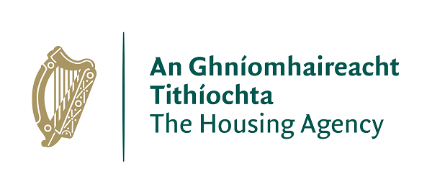 | Housing Agency Housing Education Bursary Scheme 2021/2022

The Housing Agency is delighted to launch its Housing Education Bursary Scheme for the 2021/2022 academic year.

Recent years have seen significant developments in the areas of housing delivery and policy. Housing professionals will play a key role in shaping future developments in the sector. The Housing Agency is committed to supporting the education, training, and development of housing practitioners, as well as those interested in developing a career in housing. The Housing Education Bursary Scheme will empower housing professionals to build resilient and sustainable communities in Ireland.

The Bursary Scheme will support students seeking to enrol on the following courses offered by the Institute of Public Administration and the Irish Council for Social Housing:

- IPA NFQ Level 6 (Special Purpose Award) Certificate in Housing Studies (September 2021 start)
Further details: Certificate in Housing Studies (ipa.ie)
- IPA NFQ Level 8 (Special Purpose Award) Professional Diploma in Housing Studies (October 2021 start)
Further details: Professional Diploma in Housing Studies (ipa.ie)
- ICSH Level 4 Certificate in Housing (January 2022 start)
Further details: Education and Training - Irish Council for Social Housing (icsh.ie)

Applicants seeking a bursary for the 2021/2022 academic year should submit the enclosed application form to the Housing Agency by the deadlines mentioned in the ‘Key Information’ section. Please note, admission to the relevant courses is separate from the bursary application: applicants must also complete the course providers’ standard course application, following the instructions of either the Institute of Public Administration (IPA) or the Irish Council for Social Housing (ICSH). The conditional award of a bursary does not guarantee admission to a course, as places are decided by the course providers.

Key Information

Value of Award

Bursaries are awarded following a competitive application process. Bursaries are intended to serve as a contribution towards course fees, and the value awarded may vary depending on demand. Successful applicants will have credit lodged with their nominated course provider on successful commencement of the course. The balance of fees will be payable to the course provider as normal.

Closing Dates

For the 2021/2022 academic year, the Bursary Scheme will be awarded in two rounds:

Round 1 relates to:

- IPA NFQ Level 6 (Special Purpose Award) Certificate in Housing Studies (September 2021 start)
Further details: Certificate in Housing Studies (ipa.ie)
- IPA NFQ Level 8 (Special Purpose Award) Professional Diploma in Housing Studies (October 2021 start)
Further details: Professional Diploma in Housing Studies (ipa.ie)
The closing date for receipt of completed bursary application forms for these courses is 5pm on August 27th, 2021. It is envisaged that notifications will be made by mid-September.

Round 2 relates to:

- ICSH Level 4 Certificate in Housing (January 2022 start)
Further details: Education and Training - Irish Council for Social Housing (icsh.ie)

The closing date for receipt of completed bursary application forms for this course is 5pm on October 11th, 2021. It is envisaged that notifications will be made by late October.

Please note that admission to courses is separate from the bursary application, and applicants must also complete the course providers’ standard course applications. Course application closing dates may differ to those of the bursary. It would be useful to enclose a note in your course application to say that you have applied for the bursary. To apply for the individual courses please follow the hyperlinks set out above.

Eligibility

It is intended that the Bursary assists those who would be otherwise unable to secure funding for the full course fees from their organisation or other sources.
All bursary applications will be screened to check eligibility. To be eligible applications must:

- Be submitted on time;
- Be completed in full, including ticking the red box consenting to the Housing Agency processing your application in accordance with the Privacy Statement detailed at Appendix 2 of the application form;
- Confirm that applicants are unable to secure 100% funding from other sources;

Evaluation of bursary applications

All eligible applications received will be assessed by a panel comprised of relevant staff from The Housing Agency. The panel will use the following marking criteria to assess eligible applications:
- The applicant has demonstrated a commitment to the housing sector or issues relevant to the housing sector in their career to date
- The applicant has demonstrated the benefit the course will have for their career and/or personal development
- The applicant has demonstrated that completing the course will allow them to contribute to the development of the housing sector and/ or their organisation.

Please respect the word count on the application form.
There is no limit to the number of applicants from individual organisations. However, if a large number of applications is received, the Housing Agency may ensure that as many organisations as possible are represented.

Further Information
Queries relating to the bursary scheme can be sent to training@housingagency.ie
For all other queries relating to the courses, please contact the Institute for Public Administration: undergrad@ipa.ie or the Irish Council for Social Housing: info@icsh.ie

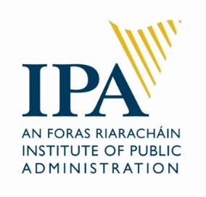
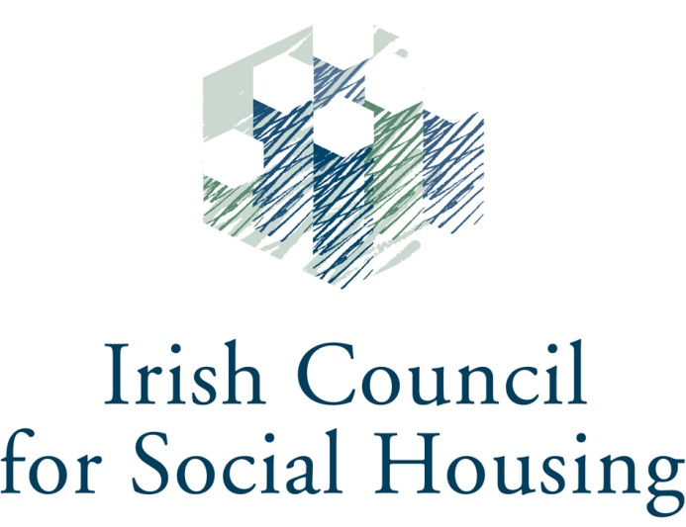

Application Form
for
The Housing Agency
Housing Education Bursary Scheme
2021/2022

Closing Dates:
Round 1: 5pm, August 27th, 2021 for IPA NFQ Level 6 and 8 (Special Purpose Award) Courses
Round 2: 5pm, October 11th, 2021 for ICSH/CIH Level 4 Course

Submission: By email only to training@housingagency.ie in PDF format

☐ Please tick this box to confirm consent to the Housing Agency processing your application in accordance with the Privacy Statement detailed at Appendix 2.
Disclaimer: please consult the documentation to ensure that you are qualified to apply for the course for which you are seeking funding. All Bursary applications will be assessed by a panel at the Housing Agency. Not all applicants may be successful, subject to funding available.

APPLICATION FORM FOR HOUSING AGENCY HOUSING EDUCATION BURSARY 2020/2021

Name
Organisation
Job Title
Email
Contact ph.
Course which you are applying for
(Please consult course descriptors at Appendix 1 and insert an ‘x’ in one box only. Ensure to apply for the course as normal noting that you have also applied for this bursary)
☐ |  |  | IPA NFQ Level 6 (Special Purpose Award) Certificate in Housing Studies (September 2021 start)
☐ |  |  | IPA NFQ Level 8 (Special Purpose Award) Professional Diploma in Housing Studies (October 2021 start)
☐ |  |  | ICSH/CIH Level 4 Certificate in Housing (January 2022 start)
Please insert an ‘x’ in the box if you are receiving funding from your employer or other sources for this course ☐
If you are receiving funding, please indicate the amount or percentage you are receiving:

Where did you hear about the bursary scheme?
Colleagues: ☐
Course provider: ☐
Housingtraining.ie: ☐
Housing Training Newsletter: ☐
Other [please specify]:

Past training/education
(Please give a brief description of any previous degrees/diplomas/training – this does not have to be housing related and is intended to give context regarding your career to date)
Year(s) | Qualification/ Course
Details of role with your current organisation
Job title |  | Employer |  | Main responsibilities
Details of previous roles/ employment (max four)
Job title |  | Employer |  | Dates | Main Responsibilities

What are your main reasons for applying for this course?
(Here we would like you to set out a short statement on why you want to partake in the course you have selected and why bursary funding would be of assistance) Max 150 Words

How do you feel participation on the course will benefit your professional development?
MAX 150 Words

How do you feel participation on the course will benefit your organisation and/or the wider housing sector? MAX 150 Words

Appendix 1 – Course Details
The following is some overview information, full details can be found at the hyperlinks set out.
Institute of Public Administration – NFQ Level 6 (Special Purpose Award) Certificate in Housing Studies

The Certificate in Housing Studies provides housing practitioners, students of public policy and anyone with an interest in housing with a comprehensive introduction to housing services and policy in Ireland. A part-time, accredited programme, it responds to a clear need among staff working in local authorities and in voluntary and co-operative housing organisations for a greater understanding of the major issues in public/social housing. The Certificate in Housing Studies will be of huge benefit to housing practitioners, in both generalist and technical positions in Local Authorities and Approved Housing Bodies. It provides a system-wide induction to public/social housing - an area of huge national importance - in a practical and applied manner. The programme will also appeal to anyone working in related areas who would like to understand the evolution of housing policy in Ireland and the work of those bodies responsible for the delivery of housing policy.

Delivery Method:
The programme will be delivered online, via live virtual teaching sessions from IPA headquarters to students at their remote location. There will be seven main modules. The modules will be delivered by IPA housing and external specialists. Subject to government guidance, we may be in the position to offer additional face to face teaching if permitted.

Entry Requirements:
Leaving Certificate. Applicants who are 21 years of age or over may qualify for entry as a mature student. Applicants who do not meet the entry requirements may apply for a Special Case Application Form.

Duration: One academic year
Accreditation: National University of Ireland
Level: NFQ Level 6 (Special Purpose Award)
Commences: 17 September 2021
Application Deadline: end-August 2021. Application forms can be downloaded from the IPA website www.ipa.ie. Completed applications should be submitted by email to undergrad@ipa.ie and will be acknowledged by email upon receipt.
Fees: €990. This includes all matriculation, tuition and examination fees.
Further details: Certificate in Housing Studies (ipa.ie)

Institute of Public Administration – NFQ Level 8 (Special Purpose Award) Professional Diploma in Housing Studies

The Professional Diploma in Housing Studies—the first course of its kind in Ireland— has been developed to provide an in-depth and analytical treatment of social and supported housing. Housing studies is a field of immense importance in Ireland and elsewhere. The provision of social and affordable housing and of different types of housing supports and rental assistance are key parts of the modern welfare state. Such provision is complex however, and affected by economic and social considerations, legislation, and broader policy frameworks. It is vitally important that those interested in housing studies—whether they work in local authorities, government departments, the voluntary and advocacy sectors, relevant state bodies or elsewhere—have expertise in the prevailing theories, the recurring issues and the contentious problems that define the contemporary housing studies field in Ireland and abroad. This professional qualification, which can be taken from anywhere in the country, will furnish students with that expertise. The programme has a very broad appeal. Students may have a personal interest in housing studies or may have professional responsibilities that would be well served by a qualification in this area. Those with a professional interest in housing often work in local government, in the civil service, in state or voluntary bodies or in advocacy organisations especially concerned with the provision and management of housing services. Whether they work in management, administrative or technical positions, this professional diploma will meet their needs by providing a comprehensive introduction to housing studies in Ireland.

Delivery Method:
The programme will be delivered online, via live virtual teaching sessions from IPA headquarters to students at their remote location. There will be seven main modules. The modules will be delivered by IPA housing and external specialists. Module webinars typically start at 9.00am and finish at 2.00pm. Subject to government guidance, we may be in the position to offer additional face to face teaching if permitted.

Entry Requirements:
Certificate in Housing Studies (accredited by IPA/UCD/NUI) or equivalent.

Duration: One academic year
Accreditation: NFQ Level 8 (Special Purpose Award)
Commences: 1 October 2021
Application Deadline: end-August 2021. Application forms can be downloaded from the IPA website www.ipa.ie. Completed applications should be submitted by email to undergrad@ipa.ie and will be acknowledged by email upon receipt.
Fees: €1,350. This includes all matriculation, tuition and examination fees.
Further details: Professional Diploma in Housing Studies (ipa.ie)

ICSH/CIH Level 4 Certificate in Housing

Since 2014, the ICSH and CIH Housing Academy have partnered to deliver the popular CIH Certificate in Housing course. This course provides a challenging and highly relevant grounding in all aspects of housing strategy, policy, law and finance for housing practitioners. Learners also learn skills in self-reflection and how to manage people, risk and change.
Aimed at housing professionals aspiring to or working at management level, the course ensures learners have a sound understanding of the context within which housing organisations operate and is delivered through a blend classroom and online learning.
The course is delivered through 6 modules
- Housing policy
- Housing management services
- Housing need, demand and supply
- Housing law
- Financing for housing
- Professional practice skills for housing
There is one full class day per module, which will be delivered either in-person or through Zoom, with dedicated online resources to support your learning. There is also one assignment to be completed per module every 7-8 weeks.

Duration: One academic year
Accreditation: QCF (Qualifications and Credit Framework England/ Northern Ireland) Level 4
Commences: January 2022
Application Deadline: 11 October 2021
Fees: €1,950 (TBC)
Further details: https://icsh.ie/our-work/education-and-training/

Appendix 2 - Your Consent
In order for the Housing Agency to accept your application form, you must provide consent for the Agency to process your Bursary Scheme application in line with the Agency’s Privacy Statement regarding Bursary Scheme Applications.
This statement (the “Privacy Statement”) aims at informing you of how the Housing Agency will use the information you submit when applying for the Bursary Scheme ("Bursary Scheme Data").
All Bursary Scheme Data you submit to the Housing Agency is retained in the Housing Agency.
This Privacy Statement covers any Bursary Scheme Data you submit, such as:
• Name, address, email address, telephone number, or other contact information;
• Information contained in your application form, such as previous work experience, education, or other information you provide for our consideration;
For the avoidance of doubt, the Housing Agency does not wish to receive any confidential or proprietary (or patented) information which you have received from your (previous) employers.
Only select employees of the Housing Agency – senior management, employees of the training team, and IT (for maintenance purposes only) will have access to your Bursary Scheme Data. The Housing Agency will not supply any data to any third party except to the provider of the training course you applied for, this will only occur if you have been awarded and have accepted a Bursary. The only data which will be shared with the training provider is your name, the course applied for, and the amount of the Bursary award.
The Bursary Scheme Data you provide will be used to assess your application and to communicate with you.
Your Bursary Scheme Data is stored in our database for three (3) years as from your most recent submission of Bursary Scheme Data.

