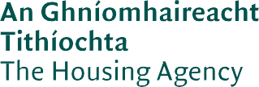

Housing Options
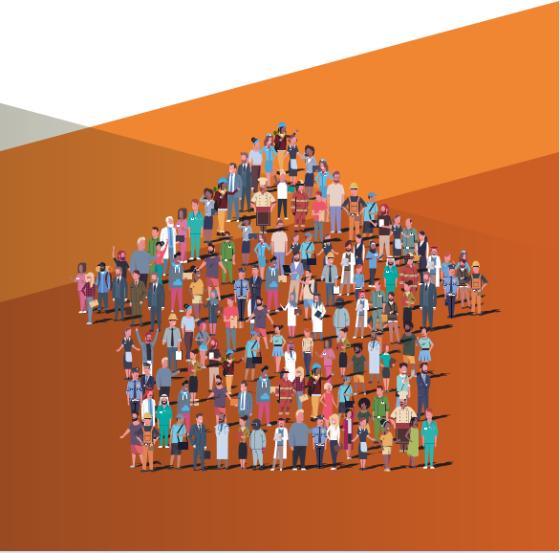
a guide to housing options available through local authorities

This document is a guide to the housing options that are available through local authorities. The document is an initial source of information.

All local authorities have websites where additional and more detailed information can be found on all the options contained in this document.

Application forms can be obtained from the Housing Section of your local authority or downloaded from their website.

Citizens Information Centres may also be in a position to access application forms and will be able to provide additional information and guidance. Citizens Information has a website www.citizensinformation.ie which also provides information on housing.

2

Contents

Purpose of Document 02
- Policy Context 05
  - Housing for All – A New Housing Plan for Ireland 05
  - National Housing Strategy for Disabled People 2022-2027 07
  - Sharing the Vision 08
  - Housing First 09
- Social Housing Support 10
  - Local Authorities 10
  - Approved Housing Bodies 11
- Social Housing Eligibility and Need 12
- Applying for Social Housing Support 13
  - Application Form 13
  - Local Connection 13
  - Areas of Choice 14
  - Additional Information 14
- Assessment 15
- Housing Waiting Lists 17
  - Choice Based Lettings 18
  - Allocation of Housing 19

- Social Housing Provisions 20
  - Local Authority Housing 20
  - Approved Housing Body Accommodation 20
  - Housing Assistance Payment (HAP) 22
  - Older Persons Accommodation 23
  - Tenant Adaptation Works 23
  - Social Leasing/Rental Accommodation Scheme 23
  - Traveller Accommodation 24
  - Caravan Loan Scheme 24
- Grants for Adaptations 25
  - The Housing Adaptation Grant for People with a Disability 25
  - Mobility Aids Housing Grant Scheme 26
  - Housing Aid for Older People 28
  - Disabled Persons Grant Scheme 29
- Affordable Housing Schemes 30
  - Local Authority Home Loan 30
  - Cost Rental 32
  - The First Home Scheme 33
  - Croí Cónaithe (Towns) Fund Scheme 34
- Further Information 35

Policy Context

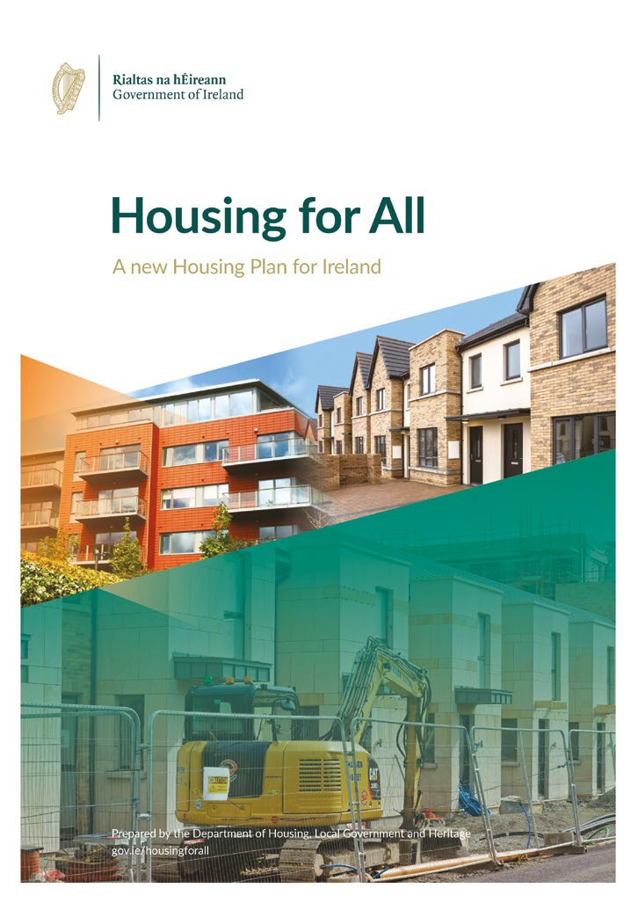Housing for All – A New Housing Plan for Ireland
Housing for All (2021) is the Government’s housing plan to 2030. The overall aim of the housing plan for Ireland is that everyone in the State should have access to a home to purchase or rent at an affordable price, built to a high standard and in the right place, offering a high quality of life. The plan’s vision is to have a steady supply of housing in the correct locations with economic, social, and environmental sustainability built into the system.

Housing for All provides four pathways to achieving its overarching objectives:

Supporting Homeownership and Increasing Affordability.

Eradicating Homelessness, Increasing Social Housing Delivery and Supporting Social Inclusion.

Increasing New Housing Supply.
Addressing Vacancy and Efficient Use of Existing Stock.

Pathway 1

Supporting Homeownership and Increasing Affordability
The main objective of Pathway 1 is to promote home ownership and to ease pressure on renters. A range of measures will be delivered through the Affordable Housing Act 2021 to make home ownership available to tens of thousands of individuals and families and will reduce rental pressures for thousands of others.

Pathway 2

Eradicating Homelessness, Increasing Social Housing Delivery and Supporting Social Inclusion
The main objective of Pathway 2 is to address the needs of socially excluded members of society. Homelessness and the difficulties faced by older persons and people with disabilities will be addressed by taking further action to address needs in these areas. Protections across all tenures will be increased to support those who are in most need.

Pathway 3

Increasing New Housing Supply
The main objective of Pathway 3 is to increase the supply of new housing. The Government intends to build an average of 33,000 homes a year between now and 2030. There will be increased investment in social and affordable housing and in private housing supply. The Government will also examine State land and will activate as much supply as possible from those lands.

Pathway 4

Addressing Vacancy and Efficient Use of Existing Stock
The main objective of Pathway 4 is to ensure that housing stock is being fully utilised by bringing vacant and derelict properties back into use. It will also examine whether other types of vacant properties could be converted to residential use, and where there is potential to use existing stock more efficiently.

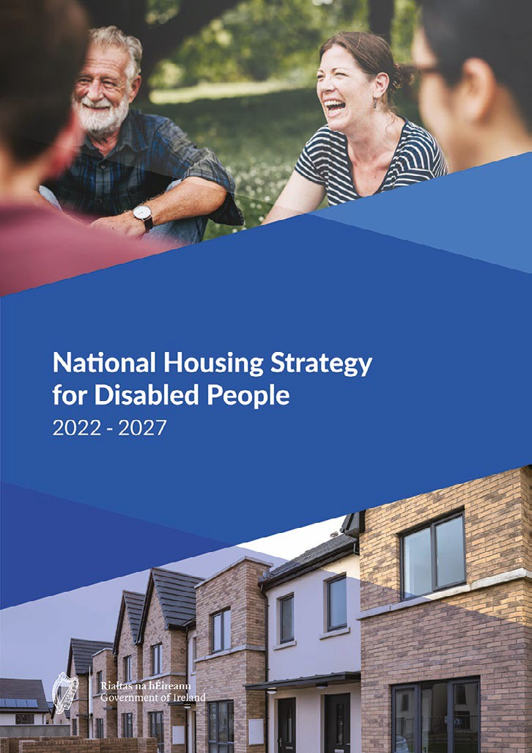The National Housing Strategy for Disabled People 2022-2027
The National Housing Strategy for Disabled People 2022 – 2027 (NHSDP) sets out the vision for the cooperation and collaboration of Government departments, state agencies and others in delivering housing and the related supports for disabled people over the next five years. The vision of this strategy is:
To facilitate disabled people to live independently with the appropriate choices and control over where, how and with whom they live, promoting their inclusion in the community.

To further enable equal access for disabled people to housing with integrated support services.

The Strategy has 6 themes. These are:

Accessible Housing and Communities
Theme 1

Interagency Collaboration and the Provision of Supports
Theme 2

Affordability of Housing
Theme 3

Communication and Access to Information
Theme 4

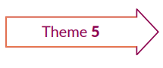

Knowledge, Capacity and Expertise
Theme 5

Strategy Alignment
Theme 6

The Strategy outlines that the delivery under these themes must be done in a coordinated and collaborative way, in line with the United Nations Convention on the Rights of Persons with Disabilities (UNCRPD) with disabled people at the centre. Delivering on “Article 19 - Living independently and being included in the community” of the UNCRPD, ensures disabled people have equal rights in
accessing housing and equal rights to accessing supports necessary to enable them to live independently within the community.

The Strategy sets out how the Government will put in place the frameworks to ensure that the housing and care/support needs of disabled people are comprehensively addressed.

Sharing the Vision

Sharing the Vision: A Mental Health Policy for Everyone (2020) is Ireland’s national mental health policy and is the successor to ‘A Vision for Change’ (2006). The
new strategy builds on the work of the previous policy and incorporates new recommendations as appropriate to enhance national policy.

Sharing the Vision sets as a policy goal that people with psychosocial disabilities or mental health difficulties require access to good-quality, secure and appropriate housing to facilitate and sustain their recovery. It outlines the importance of providing suitable housing, putting in place supports, sustaining tenancies, and
ensuring effective collaboration between government departments, state agencies, local authorities and service providers.

Sharing the Vision recommends that when local authorities are developing their local housing plans, they should liaise with statutory mental health services to include the housing needs of people with complex psychosocial disabilities or mental health difficulties. It also calls for the Department of Health and the Department of Housing, Local Government and Heritage to consult with relevant stakeholders and develop a set of rules to help people move from HSE-supported accommodation to community living.

Housing First

Housing First is a scheme that helps people with a history of rough sleeping or long-term use of emergency accommodation to get secure accommodation and maintain their tenancies. Housing First also provides supports to people who have complex needs and face challenges like mental health difficulties, alcohol or drug misuse, social or behavioural problems and other things.

It has three main parts, these are:

Permanent, affordable housing
1

Mobile case management and treatment services (mental health, health, and addiction services)
2

A programme philosophy based on client choice and recovery
3
The Housing First National Implementation Plan 2022-2026 describes the Government’s plan for Housing First. It aims to provide 1319 new tenancies over the period 2022-2026 with an average of 264 new tenancies per year.

Social Housing Support

Social housing support is housing provided by a local authority or an Approved Housing Body to people who are assessed as being unable to afford housing from their own resources.

Local Authorities

Local authorities are the main providers of social housing support in Ireland and are the biggest landlord in the State. The main purpose of the Housing Services Department in local authorities is to facilitate the provision of suitable, cost effective, quality accommodation and housing support for people in need of housing.

Housing support can be provided in a number of ways:

Rented tenancies in local authority owned properties,
Sourcing social housing properties from the private sector through schemes such as the Rental Accommodation Scheme, leasing initiatives, and the Housing Assistance Payment,

Allocations to accommodation provided by Approved Housing Bodies,
Provision of specific accommodation for homeless people, older people and Travellers,
Facilitating adaptations to existing local authority homes to meet specific household needs,

Provision of certain grants to increase accessibility in the home for people with disabilities and special needs.

Approved Housing Bodies

Approved Housing Bodies (AHBs) are independent non-profit organisations that provide:

rented housing for people who cannot afford to buy their own homes, and

specialist housing, such as housing for older people or homeless people.

They are also known as voluntary housing associations or housing co-operatives. They provide housing on a similar basis to a local authority.

Allocations to Approved Housing Body owned or leased properties is normally through the local authority in which the property is located.

Social Housing Eligibility and Need

A person’s housing need and eligibility is established by applying to a local authority for social housing support.

A person is considered eligible for social housing support when they satisfy the income criteria, and the person does not have suitable alternative accommodation that they could live in or sell to provide other housing for themselves. In addition, a person must not have been in significant arrears in another local authority property and must have the right to reside in the State if from another country.

Where a person has a housing need i.e., their current accommodation is not suitable, but is not deemed eligible for social housing, they will have to explore other options to determine how their housing need can be met from their own resources such as renting a property privately, purchasing a property or adapting their existing accommodation.

A person can obtain further information on social housing support from their local authority.
In addition, information is available through the Citizen’s Information Services in relation to both social and private housing, which can be of assistance to a person to explore their housing preferences in a real and meaningful way.1

- Housing (citizensinformation.ie)

Applying for Social Housing Support

Application Form

To apply for social housing support a person must complete and submit an application form to the local authority. A person must apply to the local authority in which they wish to receive social housing support. The application form can be obtained from the local authority or downloaded from the local authority’s website. A person can only apply to one local authority for social housing support.

An applicant for social housing must use an application form from the relevant local authority. The name of the local authority is at the top of the form.

It is important that the application form is read in full. The application form includes a checklist. The checklist should be used to ensure that all required information is submitted with the application form. An easy read guide to the completion of the application form is available from the local authority.

Incomplete applications submitted to a local authority will be returned to the person, so it is important to remember to return the full application when it has been completed.

Local Connection

A person should make their social housing application to the local authority in whose area they wish to live in. This does not have to be the area where they currently live. When a person does not currently live in the area they wish to live in, they will
be asked to demonstrate that they have a connection to the area that they have chosen. This connection can be through family, employment, education or medical needs.

Areas of Choice

When applying for social housing support a person can specify up to three areas within the overall local authority area where they would like to live. If there is more than one local
authority in their county of application, they may be able to indicate an area preference within the alternative local authority of that county. Speak to the local authority for more information. Careful consideration should be given to the selection of these areas as only suitable housing in these areas will be offered to the person. Consideration should be made based on things such as services, transport, links to family and friends, and availability of suitable housing in the areas of choice.

Additional Information

If a person is applying for social housing support based on their medical or disability grounds, they must complete a Medical and/or Disability Information Form (HMD-Form 1). This is available from their local authority and should be submitted with the application form.

Assessment

Each completed application is assessed by the local authority to determine if the person is ‘eligible’ for housing and ‘in need’ of housing.

In assessing the application, the local authority will consider such factors as:

Household size, Household income,
Present accommodation (if any),
The condition of present accommodation (if any),
Other relevant information such as specific requirements due to a disability or medical circumstances,

The term ‘household’ on the application form is the number of people seeking accommodation together. This may be one or more people.

When assessing an application for social housing the local authority is firstly looking to establish that the person is ‘eligible’ for social housing. Eligibility is based on:

Income limits,
Right to reside in the State on a long-term basis,
No significant history of rent arrears with a local authority, Person does not own a house that they could live in.

Secondly, the local authority will also determine the ‘need’ for social housing. To do this, local authorities will consider the circumstances of the person applying, for example:
Are they living in overcrowded or unfit accommodation?
Is there need for specific accommodation because of a disability?

Are they living in an institution, emergency accommodation or hostel?

Are they homeless or is there a risk of homelessness?
If sharing the accommodation, does the person have a need for separate accommodation?

Does the person have an unsustainable mortgage?
Is the person unable to provide accommodation from their own resources?

When eligibility is established, and it is determined that the person needs social housing, a person is deemed to ‘qualify’ for social housing. At this point the person is placed on the Record of Qualified Households. This is commonly known as the Housing Waiting List. This is how local authorities plan for the delivery of suitable accommodation that will meet the needs of applicants.

If households are deemed ineligible for social housing they could have their short-term housing need met in the private sector with the assistance of Rent Supplement, funded by the Department of Social Protection. Rent Supplement is paid to people living in private rented accommodation who cannot provide for the cost of their accommodation from their own resources. The amount of Rent Supplement provided is calculated to ensure that income, after paying rent, does not fall below a minimum level.

Housing Waiting Lists

Every person that has applied for social housing and is deemed to qualify, is placed on the local authority Housing Waiting List.

Each local authority holds and manages the Housing Waiting List for its own administrative area. Individuals can be allocated housing in Approved Housing Body owned properties by being nominated by the local authority from the Housing Waiting Lists.

Each local authority can determine the order of priority that applies to their waiting list. These are called the ‘schemes of letting priorities’. Most local authorities operate a “time on list” system, whereby priority is given to those with most time spent on the waiting list. However, there are priority categories operated by some local authorities. Details of these can be obtained from each local authority.

Local authorities may also have specific waiting lists for:

Older persons accommodation (typically over 55 years), Homeless persons,
Traveller specific accommodation.

Choice Based Lettings

Several local authorities have a system called Choice Based Lettings (CBL). The local authorities advertise CBL properties on their Choice Based Lettings website where those approved for social housing can express an interest in properties that become available under this system.

To be eligible for a particular property, the property must be suitable to the applicant’s needs. Choice Based Lettings allows a person who is on the Housing Waiting List to make decisions over where they live and type of tenure (local authority, Approved Housing Body and leased homes).

Each applicant is given a unique Username and Pin to access the website when they are approved to be included on the housing list. As houses and flats become available under CBL, they are allocated to those on the waiting list in order of priority, taking account of all the relevant circumstances.

For those who do not have access to a computer they can contact their local authority directly for further information on how to register their interest for CBL homes.

Allocation of Housing

Allocations can be made to accommodation provided directly by local authorities or to accommodation provided by Approved Housing Bodies.

When the local authority is planning to make an offer of accommodation, it must review its assessment of the household’s eligibility and need for social housing. It may also confirm that the application is still valid as regards connection with the area and selection of ‘area of choice’. They may also check that the person’s circumstances have not changed resulting in them being deemed ineligible for social housing support. When the accommodation becomes available the local authority will offer the property to a person on the Housing Waiting List.

When accommodation is provided by Approved Housing Bodies, the local authority nominates a person from the Housing Waiting List to take up the tenancy. Once this person is accepted as a tenant by the Approved Housing Body, the local authority deems that the accommodation need of the person has been met.

It should be noted that most local authority and Approved Housing Body housing is unfurnished. It is possible to make an application to the Department of Social Protection for financial assistance towards the purchase of goods and appliances; this is called an Exceptional Needs Payment. These payments are made under the Supplementary Welfare Allowance Scheme.

Social Housing Provisions

Local Authority Housing

Local authorities continue to be the largest landlord in the country. It is expected that this will be the case for the foreseeable future. Local authorities will continue to manage their stock including the allocations of vacancies that arise. A tenant of a local authority will pay an income related differential rent.

Approved Housing Body Accommodation

Approved Housing Bodies have become a significant provider of social housing support. There are over 500 Approved Housing Bodies in Ireland providing over 35,000 homes across the country.

The housing provided by these bodies includes:

General housing,
Older persons accommodation,
Housing for people with disabilities including mental health issues, and

Homeless accommodation.

To avail of Approved Housing Body owned accommodation an individual/ household must qualify for social housing support with the local authority. The local authority will then put forward applicants to the Approved Housing Body in line with their allocation policy.

Some Approved Housing Bodies deal primarily with general housing provision while others have a more specialised role. This means that not all AHBs operate their allocations system through the local authorities, some have their own system for allocating housing.

Approved Housing Bodies provide accommodation through:

New build, Purchases, and
Leasing in the private market.

While Approved Housing Bodies access private finance to fund some of their development/purchases, they also receive funding from the State through the local authorities under a number of schemes.

Housing Assistance Payment (HAP)

The Housing Assistance Payment (HAP) is a social housing support administered by local authorities. Any household that is qualified for social housing support and is not already in receipt of another form of such support, is eligible for HAP. This includes new social housing applicants, those on the housing list and long-term Rent Supplement recipients referred from the Department of Social Protection.

HAP households that qualify for social housing support must find their own accommodation in the private rental sector. The accommodation can be within the local authority area for which they qualified for social housing support, or another local authority. Support through HAP is subject to rent limits. There is some flexibility for local authorities to approve HAP that exceed these limits if the applicant cannot find accommodation within the limits. The local authority will make payments towards the rent on behalf of the household to the landlord and the household will pay an income-based rent to the local authority. Under HAP,
a recipient is allowed to work full time and continue to benefit from HAP. The level of HAP and rent to the local authority will be adjusted accordingly to reflect changes in household income.

To access HAP, applicants must contact their local authority. The local authority will provide the person with a HAP pack including an application form. Once the form is completed and returned to the local authority, the application will be assessed, and the applicant will be informed of the outcome of the assessment.

If the application is approved payments will commence and the local authority will arrange to inspect the accommodation within eight months of the first HAP payment made to the landlord. This is to make sure that the accommodation meets the rental housing standards that apply to all privately rented properties.
All local authorities use the services of the HAP Shared Services Centre, which is based in Limerick, to collect all rents from HAP tenants and to make all HAP rental payments to landlords.

For more information on HAP, please contact your local authority or go to www.hap.ie.

Older Persons Accommodation

Some local authorities provide special accommodation for older people – usually community accommodation with special features.

Tenant Adaptation Works

The scheme is available for local authority tenants who require adaptations to be carried out to their local authority home to assist with their disability needs. A local authority will normally consider all options available prior to adapting a property including consideration of the tenant transferring to a more suitable property.

Social Leasing/Rental Accommodation Scheme

Long-term social leasing (10 - 25 years), Short-term leasing and the Rental Accommodation Scheme (RAS) are forms of social housing support provided to households through the private sector.
Landlords can put their properties forward and if the property is suitable, the local authority will nominate a household to that property. The tenant pays a differential rent to the local authority and the local authority will make payments to the landlord on behalf of the tenant.

These options are available to all people who qualify for social housing supports, including those moving from congregated settings and those residing in the community requiring housing on disability/medical grounds.

Information on the RAS is available on the website of the Department of Housing, Local Government and Heritage.2

- gov.ie - Rental Accommodation Scheme (www.gov.ie)

Traveller Accommodation

A range of options are available for Travellers. These include standard local authority housing, private rented or private housing assisted by a local authority or voluntary organisations. Traveller specific accommodation which receives 100% capital funding from the Department of Housing, Local Government and Heritage is also available, including group housing schemes and halting sites.

Caravan Loan Scheme

This scheme is to support the provision of Traveller-specific accommodation through local authorities to provide preferential loans to Travellers to purchase their own caravan/mobile home on halting sites for use as their primary residence. There is a new pilot scheme in place which will be reviewed at the end of 2022 with a view to supporting the introduction of an enduring scheme.

Some of the conditions of this scheme are:

Loans can only be advanced to a person who the local authority deems in need of accommodation,

The maximum amount of the loan is up to €40,000 inclusive
of VAT. The owner of the caravan must provide 5% of the purchase price,

To ensure affordability, the monthly loan repayments will be calculated at a preferential rate based on the price of the caravan/mobile and the income of the household,
The loan will be for a set period of time which will be agreed in advance and based on the expected life-span of the caravan/mobile,
If a family requires additional accommodation, for example where there is overcrowding, additional funding may be available.

For further information contact your local authority or visit
https://www.gov.ie/en/publication/5ff69-housing-for-all-updates/

Grants for Adaptations

To assist a person to live in their home the local authorities offer a number of grants:

The Housing Adaptation Grant for People with a Disability

The Housing Adaptation Grant for People with a Disability assists disabled people in having adaptations carried out to make a house more suitable for them to live in. The person’s disability must be lasting and involve physical, sensory, mental health or intellectual impairment. The types of works covered include the fitting of access ramps, grab rails, downstairs toilet, stair-lifts, level access showers, changes to allow wheelchair access, extensions, and any other works which are reasonably necessary to make a house more suitable to live in.

A home can qualify for this grant if it is any of the following:

Privately owned,
Rented from a landlord with a current tenancy agreement registered with the Residential Tenancies Board (RTB) and with the landlord’s permission to make the changes,

Provided by an Approved Housing Body (a list of these can be found at
www.housing.gov.ie),

A communal residence (accommodation where people live together in group homes).
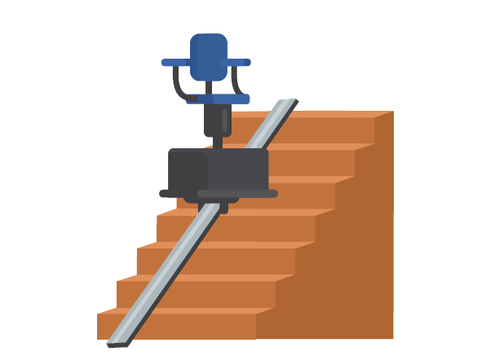

An Occupational Therapist’s (OT) report is required recommending the proposed works. The availability and the level of grant is determined on the basis of:
Gross income of everyone in the household that are over 18 years of age (over 23 if a full-time student) for the previous tax year,

Grant amounts are calculated on the net cost of the approved proposed works.

The maximum grant available is €30,000 which may cover up to 95% of the approved cost of works. Prioritisation of eligibility will be based on medical and financial need with 95% of the approved cost of work available to those with annual household incomes of less than €30,000 tapering to 30% for those with annual household incomes of €60,000.

Approval for the works must be obtained before the work starts and payment of the grant is made when the work is completed.

Mobility Aids Housing Grant Scheme

The Mobility Aids Housing Grant Scheme is available to fast-track grant aid to cover a basic suite of works to address mobility problems, primarily, but not exclusively, associated with ageing.

The works eligible under the scheme include:

Grab-rails, Access ramps,
Level access showers, Stair-lifts, and
Other minor works deemed necessary to facilitate the mobility needs of a member of a household.

A home can qualify for this grant if it is any of the following:

Privately owned,
Rented from a landlord with a current tenancy agreement registered with the Residential Tenancies Board (RTB) and with the landlord’s permission to make the changes,

Provided by an Approved Housing Body
(a list of these can be found at www.housing.gov.ie),

A communal residence (accommodation where people live together in group homes).

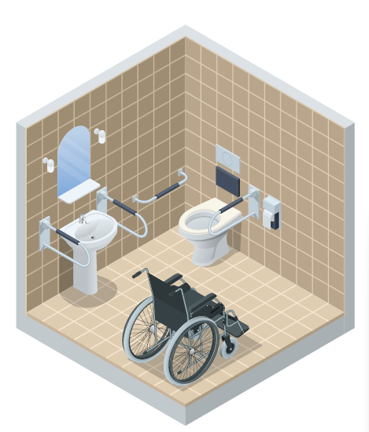
An occupational therapist’s report is required, outlining the recommendation of the proposed works.

The grant is means tested and the level of grant is determined based on gross income of each member of the household over 18 years of age (over 23 if full time student) for the previous
tax year. Gross income of household members must not exceed €30,000.

The maximum grant available is €6,000 or 100% of the approved net cost of proposed works.

This scheme can also be accessed by a disabled person.

Housing Aid for Older People

The scheme of Housing Aid for Older People is available to assist older people living in poor housing conditions to have necessary repairs or improvements carried out.

Grants under the Housing Aid for Older People Scheme may be paid, where appropriate, in respect of works carried out to a home that is privately owned where the older person:
owns the home, or
has a right to live in the home (right of residence) where the work will be done.

The types of works eligible under the scheme include:

Re-roofing: Applicants applying to carry out roof repairs/ replacement will be required to submit with their application, written confirmation from their insurance company that such repairs are not covered by their existing insurance policy,

Rewiring: Applicants applying to carry out rewiring must enclose with their application, written confirmation from a qualified electrician stating the condition of the existing wiring,

The provision of central heating, water and sanitary services (where none exists),

Repairs to or replacement of windows and doors: grant aid will only be provided in exceptional circumstances,

Dry-lining,
Other – any other repair or improvement works which in the opinion of the local authority are considered reasonably necessary.

The level of grant available based on an assessment of household income is set out in the following table:

Gross maximum household income p.a. | % of costs available | Maximum Grant available
Up to €30,000 | 95% | €8,000
€30,001 - €35,000 | 85% | €6,800
€35,001 - €40,000 | 75% | €6,000
€40,001 - €50,000 | 50% | €4,000
€50,001 - €60,000 | 30% | €2,400
In excess of €60,000 | No grant is payable | No grant is payable

Disabled Persons Grant Scheme

This grant scheme is available for people living in social housing. It provides funding for extensions and adaptations to existing social housing stock for older people and for disabled people. The grant provides funding for adaptations such as grab rails, disabled access ramps, wet rooms and downstairs bedrooms.

The scheme also provides extensions in cases of overcrowding. Government funding meets 90% of the cost of works in each property, with the local authority providing the remaining 10%.

If you are a local authority tenant and require work to be carried out in your home, you should contact your local authority for more information.

Affordable Housing Schemes

Local Authority Home Loan

A Local Authority Home Loan is a Government backed mortgage for first time buyers or other eligible applicants through local authorities. The scheme is for the purchase of new or second- hand residential properties and for self-builds. It also includes the purchase of homes through State schemes such as the Tenant Purchase Scheme and Affordable Housing Schemes but does not include the First Home Scheme.

The Local Authority Home Loan has been available nationwide from all local authorities since the 4th January 2022. The loan is a normal mortgage which is repaid by direct debit on a monthly basis. A person can borrow up to 90% of the market value of the property.

Maximum market values of the property that can be purchased or self-built are:

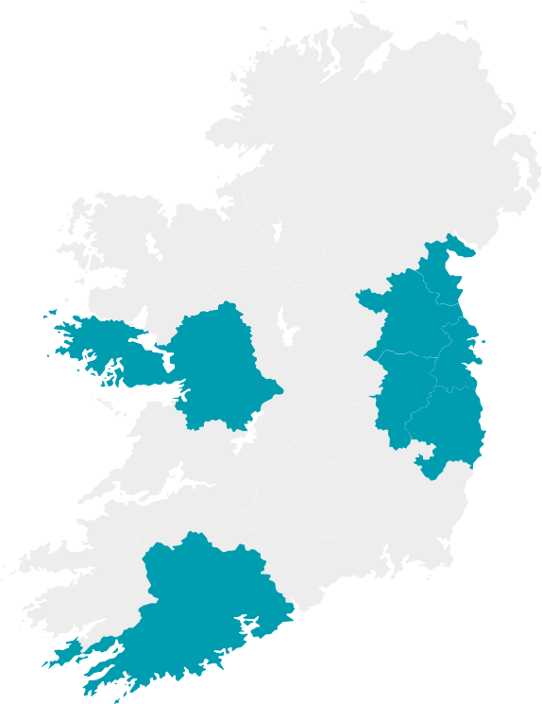
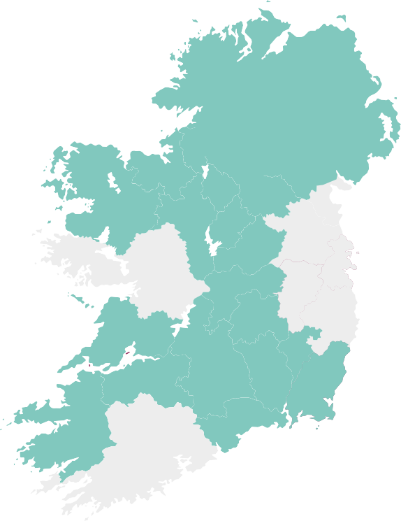

€320,000
in the counties of Cork, Dublin, Galway, Kildare, Louth, Meath and Wicklow.

€250,000
in the rest of the country.

To be eligible for a Local Authority Home Loan a person must meet certain criteria, including:
Be a first-time buyer,
Be aged between 18 and 70 years,
Be in continuous employment for a minimum of two years, as the primary earner or be in continuous employment for a minimum of one year, as a secondary earner,

As a single applicant have an annual gross income of not more than €65,000 in counties Cork, Dublin, Galway, Kildare, Louth, Meath and Wicklow and be earning under €50,000 in all other counties,

As joint applicants have an annual gross income of not more than
€75,000 in all counties.

For further information and for the full eligibility criteria, you can visit
www.localauthorityhomeloan.ie

Cost Rental

Cost Rental is a new form of public housing in Ireland and was introduced under Housing for All. It is targeted at people who are above the social housing income limits, and who want to rent or are unable to buy their own home.

Under this scheme rents charged only cover the cost of developing, financing, managing and maintaining the homes. It also offers long-term security of tenure. Cost Rental will deliver properties with rents that are at least 25% below what they would be on the private market. The Government plans to provide an average of 2,000 Cost Rental homes per year during the lifetime of Housing for All.

To qualify for the Cost Rental scheme a person must:

Have a net household income below €53,000 per annum,
Not be in receipt of any form of social housing support (including a HAP payment),

Not own a property,
Have a household size appropriate to the size of the property advertised,

Be able to afford to pay the rent for the property,
Have only entered one application for cost rental property per development.

The First Home Scheme
The First Home Scheme (FHS) aims to make home ownership achievable for thousands of individuals and families by helping first-time buyers and other eligible homebuyers make up the difference between their deposit and mortgage, and the price of their new home.
The First Home Scheme is a shared equity scheme. The FHS can fund up to 30% of the market value of your new property.
This means that homebuyers can receive funds from the Scheme in return for the FHS taking a percentage ownership in the property purchased.
A person must meet certain criteria including:

Be over 18 years of age,
Be a first-time buyer or other eligible homebuyer,
Have a mortgage approval with a Participating Lender3,
Borrow the maximum amount available to you from one of the Participating Lenders,

Have a minimum deposit of 10% of the property purchase price.
The property you are purchasing must meet certain criteria including:

Be a newly built house or apartment in a private development in the Republic of Ireland,

Be bought as the home you intend to live in,
Be within the local authority price guidelines for the property type (house or apartment),

Not be a self-build.
For further information and for the full list of eligibility criteria you can visit
www.firsthomescheme.ie

- A Participating Lender is an authorised mortgage lender that invests in the First Home Scheme and becomes a shareholder in the properties they help to fund.

Croí Cónaithe (Towns) Fund Scheme

The Croí Cónaithe (Towns) Fund aims to provide new choices for people to live in towns and villages in Ireland. It is delivered by local authorities and involves a grant being provided to support the refurbishment of vacant properties.

A person can apply for a grant of up to €30,000 for the refurbishment of vacant properties. The property must be intended to be lived in. This includes the refurbishment of a property which has not been used as residential property previously. The grant is inclusive of VAT cost of the works.

Where the refurbishment costs are expected to go above the standard grant of
€30,000, a maximum top-up grant amount of up to €20,000 will be available where the property is confirmed by the applicant to be derelict (i.e. structurally unsound and dangerous). This can bring the total grant available for a derelict property up to a maximum of €50,000.

For further information on the eligibility criteria for the scheme, you can visit www.gov.ie.

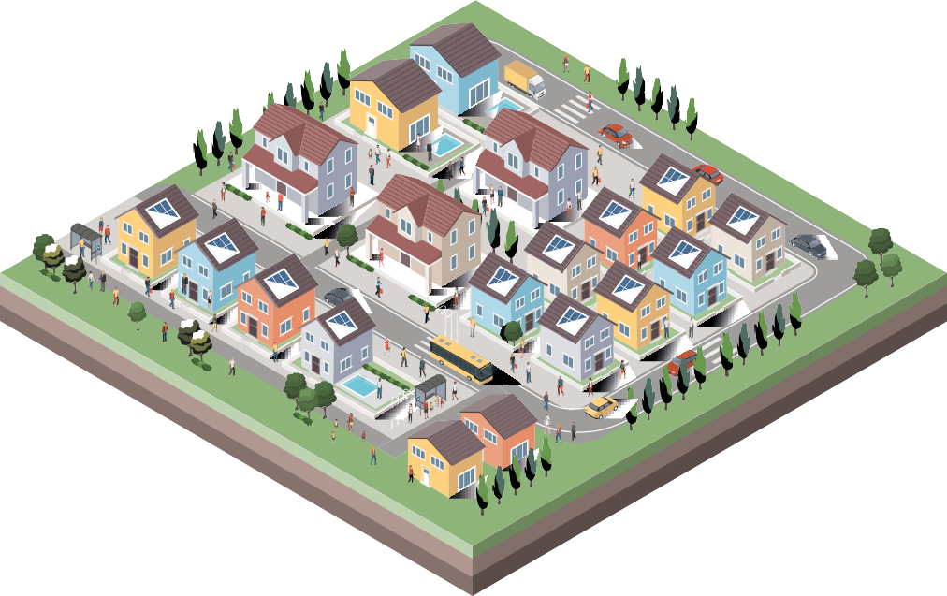

Further Information

Further information on any topic covered in this document can be obtained from a person’s local authority office or from Citizens Information Centres. Information is also available on the web. Some useful websites:

gov.ie - Local Authorities (www.gov.ie) www.citizensinformation.ie www.housingagency.ie www.housing.gov.ie
www.rtb.ie

An Ghniomhaireacht Tithiochta
36 The Housing Agency

