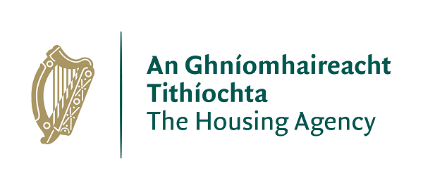 | The Housing Agency  Housing Education Bursary Scheme 2023/2024
The Housing Agency is delighted to launch its Housing Education Bursary Scheme for the 2023/2024 academic year.

Recent years have seen significant developments in the areas of housing delivery and policy. Housing professionals will play a key role in shaping future developments in the sector. The Housing Agency is committed to supporting the education, training, and development of housing practitioners, as well as those interested in developing a career in housing. The Housing Education Bursary Scheme will empower housing professionals to build resilient and sustainable communities in Ireland.

The Bursary Scheme will support students seeking to enrol on the following courses offered by the Institute of Public Administration (IPA) and the Irish Council for Social Housing (ICSH):

- IPA NFQ Level 6 (Special Purpose Award) Certificate in Housing Studies
(September 2023 start)

Further details: Certificate in Housing Studies (ipa.ie)

- IPA NFQ Level 8 (Special Purpose Award) Professional Diploma in Housing Studies
(September 2023 start)

Further details: Professional Diploma in Housing Studies (ipa.ie)

- ICSH Level 4 Certificate in Housing
(January 2023 start)

Further details: Education and Training - Irish Council for Social Housing (icsh.ie)

Applicants seeking a bursary for the 2023/2024 academic year should submit the enclosed application form to The Housing Agency by the deadlines set out in the ‘Key Information’ section of this document.

Please note, admission to the relevant course is separate from the bursary application: applicants must also complete the course providers’ standard course application, following the instructions of either the IPA or the ICSH to which they are applying to.

The conditional award of a bursary from The Housing Agency does not guarantee admission to a course, as places on each course are decided by the respective course providers.

Key Information

Value of Award

Bursaries are awarded following a competitive application process. Bursaries are intended to serve as a contribution towards course fees, and the value awarded may vary depending on demand. Successful applicants will have credit lodged with their nominated course provider on successful commencement of the course. Any balance of fees will be payable by the applicant to the course provider.

Bursary Application Closing Dates

For the 2023/2024 academic year, the Bursary Scheme will be awarded in two rounds:

Round 1 relates to:

- IPA NFQ Level 6 (Special Purpose Award) Certificate in Housing Studies
(September 2023 start)
Further details: Certificate in Housing Studies (ipa.ie)

- IPA NFQ Level 8 (Special Purpose Award) Professional Diploma in Housing Studies (September 2023 start)
Further details: Professional Diploma in Housing Studies (ipa.ie)
The closing date for receipt by The Housing Agency of completed bursary application forms for these courses is 5pm on 1st September 2023.

It is envisaged that notifications will be made by mid-September.

Round 2 relates to:

- ICSH Level 4 Certificate in Housing
(January 2024 start)
Further details: Education and Training - Irish Council for Social Housing (icsh.ie)

The closing date for receipt by The Housing Agency of completed bursary application forms for this course is 5pm on 1st November 2023.

It is envisaged that notifications will be made by mid-November.

Course Application Closing Dates

Please note that admission to courses is separate from the bursary application, and applicants must also complete the course providers’ standard course applications.

Course application closing dates may differ to those of the Bursary Scheme. It would be useful to enclose a note in your course application to say that you have applied for the bursary with The Housing Agency. For further information on how to apply for a course place, please follow the hyperlinks set out above for your chosen course.

Eligibility

It is intended that the Bursary assists those who would be otherwise unable to secure funding for the full course fees from their organisation or other sources.

All bursary applications will be screened to check eligibility. To be eligible applications must:

- Be submitted on time;
- Be completed in full, including ticking the red box consenting to The Housing Agency processing your application in accordance with the Privacy Statement detailed at Appendix 2 of the application form;
- Confirm if potentially eligible for funding for course fees, partial or otherwise, from another source;

Evaluation of Bursary Applications

All eligible applications received will be assessed by a panel comprised of relevant staff from The Housing Agency. The panel will use the following marking criteria to assess eligible applications:

- The applicant has demonstrated a commitment to the housing sector or issues relevant to the housing sector in their career to date.
- The applicant has demonstrated the benefit the course will have for their career and/or personal development.
- The applicant has demonstrated that completing the course will allow them to contribute to the development of the housing sector and/ or their organisation.

Please respect the word count limit on the application form.

There is no limit to the number of applicants from individual organisations. However, if a large number of applications is received, The Housing Agency may endeavour to ensure that the bursary is distributed among as broad a representation of organisations as possible.

Further Information

Queries relating to the bursary scheme can be sent to training@housingagency.ie.

For all other queries relating to the specific courses, please contact the Institute for Public Administration: undergrad@ipa.ie, or the Irish Council for Social Housing: info@icsh.ie.

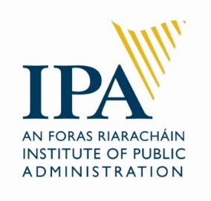
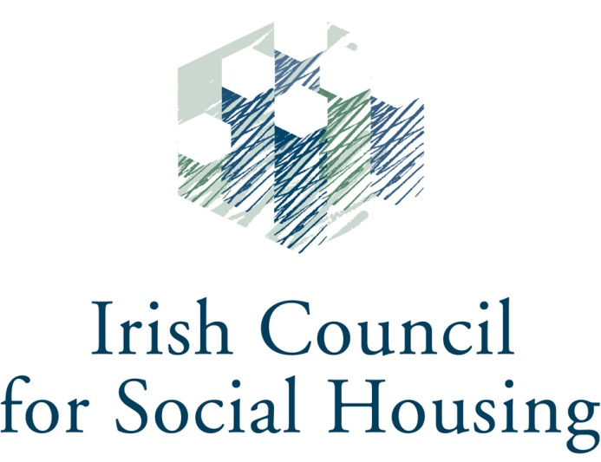

Application Form

The Housing Agency
Housing Education Bursary Scheme
2023/2024

Application Closing Dates:

Round 1: 5pm,1st September 2023 for IPA NFQ Level 6 and 8 Courses.

Round 2: 5pm, 1st November 2023 for ICSH Level 4 Course.

Submission is by email only to training@housingagency.ie in PDF format.

☐ Please tick this box to confirm consent to The Housing Agency processing your application in accordance with the Privacy Statement detailed at Appendix 2.

Disclaimer: please consult the documentation to ensure that you are qualified to apply for the course for which you are seeking funding. All bursary applications will be assessed by a panel at The Housing Agency. Not all applicants may be successful, awards are subject to funding available.

APPLICATION FORM FOR THE HOUSING AGENCY HOUSING EDUCATION BURSARY 2023/2024

Name
Organisation
(if applicable)
Job Title
(if applicable)
Email
Phone
Course which you are applying for;
(Please consult course descriptors at Appendix 1 and insert an ‘x’ in one box only. Ensure to apply to the IPA / ICSH for the course place as normal noting that you have also applied for this bursary.)
☐ | IPA NFQ Level 6 (Special Purpose Award) Certificate in Housing Studies  (September 2023 start)
☐ | IPA NFQ Level 8 (Special Purpose Award) Professional Diploma in Housing Studies  (September 2023 start)
☐ | ICSH Level 4 Certificate in Housing  (January 2024 start)
Please insert an ‘x’ in the box if you are eligible for funding from your employer or other sources for this course ☐
If you are eligible to receive funding, please indicate the amount or percentage you may receive:

Where did you hear about the bursary scheme?
Colleagues: ☐
Course provider: ☐
Housingtraining.ie: ☐
Housing Training Newsletter: ☐
Other [please specify]:

Past Training / Education
(Please give a brief description of any previous degrees / diplomas / training – these do not have to be housing related and is intended to give context regarding your career to date)
Year(s) | Qualification / Course
Details of role with your current organisation;
Job title | Employer | Main responsibilities
Details of previous roles / employment (maximum of four);
Job title | Employer | Dates | Main Responsibilities

What are your main reasons for applying for this course?
(Here we would like you to set out a short statement on why you want to partake in the course you have selected and why bursary funding would be of assistance) Max 150 Words

Please explain why participation on the course will benefit your professional development:
(MAX 150 Words)

Please explain how participation on the course will benefit your organisation and/or the wider housing sector:
(MAX 150 Words)

Appendix 1 – Course Details
The following is some overview information, full details can be found at the hyperlinks set out.
Institute of Public Administration – NFQ Level 6 (Special Purpose Award) Certificate in Housing Studies

The Certificate in Housing Studies provides housing practitioners and students of public policy with a comprehensive introduction to the major issues in public/social housing services and policy in Ireland. A part-time, accredited programme, it provides a system-wide induction to this area of huge national importance in a practical and applied manner.

The programme, therefore, will be of particular benefit to housing practitioners – in both generalist and technical positions – in local authorities and in voluntary and co-operative housing organisations. The programme will also appeal to anyone working in related areas who would like to understand the evolution of housing policy in Ireland.

Delivery Method: The programme is delivered through a blended learning model. Students attend a combination of in-person seminars at the IPA and online webinars. Students are supported in their studies by bespoke course material and online resources. There are seven seminars, delivered by the Course Director, Dr Philip Byrne, and a team of IPA housing and external specialists.

Entry Requirements: Leaving Certificate. Applicants who are 21 years of age or over may qualify for entry as a mature student. Applicants who do not meet the entry requirements may apply for a Special Case Application Form.

Duration: One academic year.
Accreditation: National University of Ireland.
Level: NFQ Level 6 (Special Purpose Award).
Commences: September 2023.
Application Deadline: end August 2023.

Application forms can be downloaded from the IPA website www.ipa.ie. Completed applications should be submitted by email to undergrad@ipa.ie and will be acknowledged by email upon receipt. Course confirmations will issue by email to confirmed students in early September.

Fees: €1,200. This includes NUI matriculation fee, tuition fee, library, examination fee and membership of the IPA.
Further details: Certificate in Housing Studies (ipa.ie)

Institute of Public Administration – NFQ Level 8 (Special Purpose Award) Professional Diploma in Housing Studies

Housing studies is a field of immense importance in Ireland and elsewhere. The provision of social and affordable housing and of different types of housing supports and rental assistance are key parts of the modern welfare state. Such provision is complex, however, and affected by economic and social considerations, legislation, and broader policy frameworks.

It is vitally important that those interested in housing studies—whether they work in local authorities, government departments, the voluntary and advocacy sectors, relevant state bodies or elsewhere—have expertise in the prevailing theories, the recurring issues and the contentious problems that define the contemporary housing studies field in Ireland and abroad.

This professional qualification will furnish participants with that expertise, whether they have a personal interest in housing studies or have professional responsibilities for the provision of housing services in management, administrative or technical roles.

Delivery Method: The programme is delivered through a blended learning model. Students attend a combination of in-person seminars at the IPA and online webinars. Students are supported in their studies by bespoke course material and online resources. There are seven seminars, delivered by the Course Director, Dr Philip Byrne, and a team of IPA housing and external specialists.

Entry Requirements: Applicants should possess the Certificate in Housing Studies (accredited by IPA/UCD/NUI) or equivalent qualification.

Duration: One academic year.
Accreditation: NFQ Level 8 (Special Purpose Award).
Commences: September 2023.
Application Deadline: end August 2023.

Application forms can be downloaded from the IPA website www.ipa.ie. Completed applications should be submitted by email to undergrad@ipa.ie and will be acknowledged by email upon receipt. Course confirmations will issue by email to confirmed students in early September.

Fees: €1,600. This includes NUI matriculation fee, tuition fee, library, examination fee and membership of the IPA.
Further details: Professional Diploma in Housing Studies (ipa.ie)

ICSH/CIH Level 4 Certificate in Housing

Since 2014, the ICSH and CIH Housing Academy have partnered to deliver the popular CIH Certificate in Housing course. This course provides a challenging and highly relevant grounding in all aspects of housing strategy, policy, law and finance for housing practitioners. Learners also learn skills in self-reflection and how to manage people, risk and change.
Aimed at housing professionals aspiring to or working at management level, the course ensures learners have a sound understanding of the context within which housing organisations operate and is delivered through a blend classroom and online learning.
The course is delivered through 6 modules
- Housing policy
- Housing management services
- Housing need, demand and supply
- Housing law
- Financing for housing
- Professional practice skills for housing
There is one full class day per module, which will be delivered either in-person or through Zoom, with dedicated online resources to support your learning. There is also one assignment to be completed per module every 7-8 weeks.

Duration: One academic year.
Accreditation: QCF (Qualifications and Credit Framework England/ Northern Ireland) Level 4.
Commences: January 2024
Application Deadline: 1 November 2023
Fees: TBC
Further details: https://icsh.ie/our-work/education-and-training/.

Appendix 2 - Your Consent
In order for the Housing Agency to accept your application form, you must provide consent for the Agency to process your Bursary Scheme application in line with the Agency’s Privacy Statement regarding Bursary Scheme Applications.
This statement (the “Privacy Statement”) aims at informing you of how the Housing Agency will use the information you submit when applying for the Bursary Scheme ("Bursary Scheme Data").
All Bursary Scheme Data you submit to the Housing Agency is retained in the Housing Agency.
This Privacy Statement covers any Bursary Scheme Data you submit, such as:
• Name, address, email address, telephone number, or other contact information;
• Information contained in your application form, such as previous work experience, education, or other information you provide for our consideration;
For the avoidance of doubt, the Housing Agency does not wish to receive any confidential or proprietary (or patented) information which you have received from your (previous) employers.
Only select employees of the Housing Agency – senior management, employees of the training team, and IT (for maintenance purposes only) will have access to your Bursary Scheme Data. The Housing Agency will not supply any data to any third party except to the provider of the training course you applied for, this will only occur if you have been awarded and have accepted a Bursary. The only data which will be shared with the training provider is your name, the course applied for, and the amount of the Bursary award.
The Bursary Scheme Data you provide will be used to assess your application and to communicate with you.
Your Bursary Scheme Data is stored in our database for three (3) years as from your most recent submission of Bursary Scheme Data.

