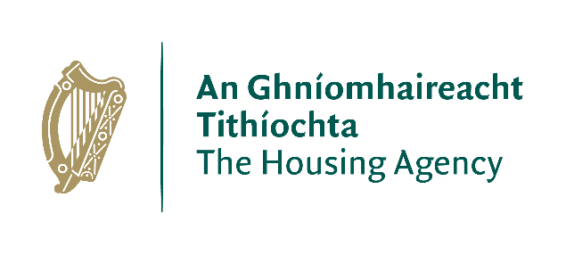

Application Form

The Housing Agency

Research Support Application Form

- All fields are mandatory
- Complete using Arial 11 point font and not less than single spacing.
- Keep within maximum word count.
- Please attach a CV for each researcher involved in the research (max 2 pages per CV)

- Email the completed and signed form in PDF format to researchsupport@housingagency.ie by 12 noon, 24th February 2020. The subject line of your email must read “Application for The Housing Agency Research Support 2020”.

Title of the Project

Name of the Applicant

1. Applicant Details

1.1 General Details

First Name (Lead Researcher)
Surname
Postal Address
Email address
Contact Address (if different)
Telephone
Email Address

Please attach CVs of those involved in the Research.

1.2 Previous Research Experience relevant to the Research Proposal [20 marks]

Research Title
Objectives
Methods
Output
Impact / Outcome
Date Started and Completed
Funding Source

Research Title
Objectives
Methods
Output
Impact / Outcome
Date Started and Completed
Funding Source
Add extra tables as required, up to a maximum of the five most relevant projects.

2. Proposed Project Details [maximum of 50 marks – a minimum score of 30 is required to qualify]

2.1 Project Proposal
Research Centre/Institute/Company
(if applicable)
Project Title:

Research Priority Area  Please tick only one area that best fits your research project. | The supply and efficient use of the housing stock
 | Understanding housing demand and affordability
 | Impact of housing on quality of life
 | Housing and people
 | Housing and sustainable communities
Project Abstract
Max 200 words: The abstract should, at a glance, provide the reader with a clear understanding of the objectives of the proposal and how they will be achieved. This summary will be used as the short description of the proposal in the evaluation process and in communications to peer reviewers and other interested parties. It must therefore be short and precise and should not contain confidential information.

Research Question:
Max 50 words: Identify the research problem/question.

Detailed Project Description
Max 1,000 words: please provide a detailed description of your project proposal outlining the objectives of the project, the methodology required, the work programme and the schedule/timeline envisaged.

3. Alignment with The Housing Agency’s Priority Areas [10 marks]

Max 500 words: Please outline how the project is in line with The Housing Agency’s Priority Areas for Research.

4. Dissemination Plans and Impact [20 marks]
Max 500 words: Please outline how the results of the research will be disseminated and the potential impact of the research.

5. Funding
To qualify for funding, full details of the research budget must be provided – this is a pass/fail criterion. If you have any queries about completion of this section, please contact: researchsupport@housingagency.ie.
Please outline the research budget here. You should specifically state the fixed overall cost for the project, including all costs. This should be broken down by:

 | € COST | € VAT | € Total
Research staff costs*
Fieldwork
Equipment
Travel and incidentals
Dissemination
Any overhead costs charged
Any other costs – specify

TOTAL
*For staff costs, please provide a separate breakdown below of cost per day for each member
of the research team.
Researcher | Number of days | Cost per day € | VAT  € | Total  €
1.
2.
3.
Total

All quoted costs must be in Euros and shall be exclusive of VAT. VAT shall be quoted separately and at the appropriate rate. Where VAT is not applicable this should be explicitly stated.

Total amount of funding requested from The Housing Agency: €________

Level of funding requested from The Housing Agency

(tick box) None 25% 50% 100%

If co-funding is being provided, list here other funders and amounts committed:

(Please provide supporting documentation)

6. Applicant Declaration

I declare that the information provided by me in this application is true to the best of my knowledge and judgement.

If successful in this application I agree to:
- Acknowledge funding received from The Housing Agency in all publications or public presentations arising from the research and inclusion of a standard disclaimer that any views expressed are not necessarily those of The Housing Agency.
- Provide a project up-date to The Housing Agency as required
- Submit an up-to-date tax clearance certificate before payment of the research grant
- Adhere to the The Housing Agency’s ethics standards.

________________________________________
Applicant Signature

The final funding decision in relation to this Scheme will rest with the The Housing Agency.

Email the completed and signed form in PDF format to 12 noon, 24th February 2020. The subject line of your email must read “Application for The Housing Agency Research Support 2020”.

